Design of Assignment 2

The design of our project started out by laying out a set of tasks necessary to fully design our end product.

The tasks we developed are as follows:

1. Read from the input file.
2. Ask user for memory and page size
3. Load processes into input queue
4. Move processes from the input queue to memory
5. Move processes out of memory and deallocate frames
6. Compute the average turnaround time

Using the six steps above we were able to develop an architecture for project 3.

To describe the working components of our architecture we provided a data flow diagram describing the set of processes that represent our message queue.

*We have also included a more detailed description of each component listed next to our diagram.*

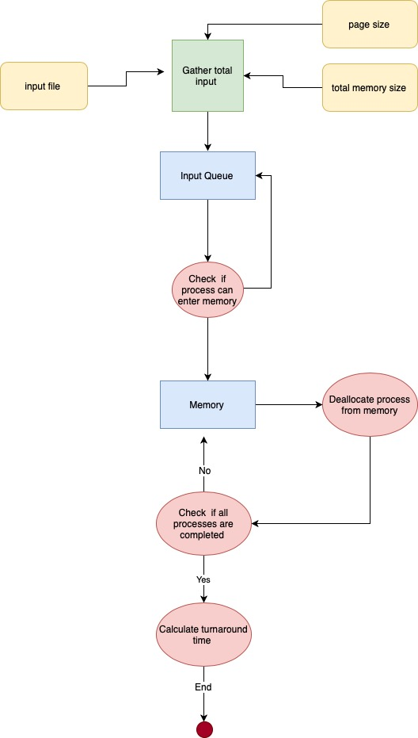

**Read input file**: The input file is read using fstream library in C++

**Ask user for memory and page size:** This functionality is done by a simple “cin” and stores the values in a variable.

**Load processes into input queue**: In order to put processes into the input queue we check if the current time is equal to a processes arrival time then we can push it into the input queue if not we ignore it.

**Move processes from the input queue to memory**: Here we checked if the total memory size of a process has enough frames that can be allocated if true we push the process into memory if false we either wait until it can be pushed to memory or if the process exceeds the total memory we ignore it.

**Move processes out of memory and deallocate frames**: Once a processes total execution time has finished we move that process out of memory and call a function which will then deallocate those frames from our data structure which represents our memory.

**Compute the average turnaround time**: To compute the average turnaround time, we took the processes total completion time (the processes completion time added to the amount of time that process was waiting in the queue) and subtract it by the processes arrival time. Then we can add the turnaround times for all the processes and then divide that number by the total amount of processes to get our average turnaround time.

The equation we used can be seen below

*total completion time = completion time + waiting time*

*n = total# processes*

$Average Turnaround time = \frac{total completion time(p1) + total completion time(p2) +..........+ total completion time(pn)}{n}$